# Chapter 3 - Modern World and Digitalization

**All Lectures Uploaded on YouTube:** [**https://tinyurl.com/fkm9-english**](https://tinyurl.com/fkm9-english)

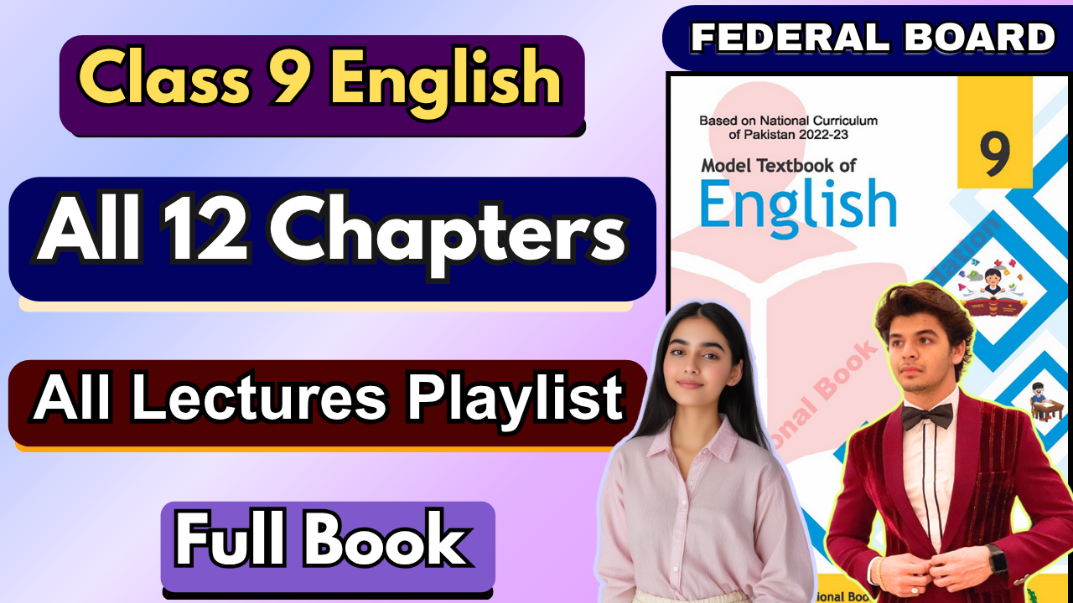

**Question and Answers**

**Q1: Define globalization with reference to business and economic development around the world.**  
**Answer**: Globalization refers to the process through which ideas, knowledge, information, goods, and services spread across the world. In a business and economic context, it is the integration of economies, enabling free trade, the free flow of capital between nations, and easy access to foreign resources such as labor markets. It maximizes economic returns for businesses by opening up new markets and lowering production costs through access to global supply chains.

**Q2: How do you think globalization has influenced the world?**

**Answer**: Globalization has profoundly reshaped the world by fostering **economic interdependence** through increased trade and investment, though this also creates national dependencies. It has driven **cultural exchange**, exposing people to diverse traditions while potentially diluting unique cultural identities. The accelerated spread of **technological advancements** has led to rapid global development, and increased interconnectedness has encouraged greater **political cooperation** on international challenges like climate change and public health.

**Q3: Shed some light on the positive role played by the media in accelerating the process of globalization.**

**Answer**: Media has been a crucial catalyst for globalization by enabling the swift **spread of information** worldwide, keeping people informed about global events and opportunities. It **facilitates cultural exchange** by showcasing diverse cultures, leading to greater understanding, and actively **supports business growth** by providing platforms for global advertising and market expansion. Ultimately, media **strengthens global connectivity** by allowing individuals and professionals to communicate and collaborate across borders.

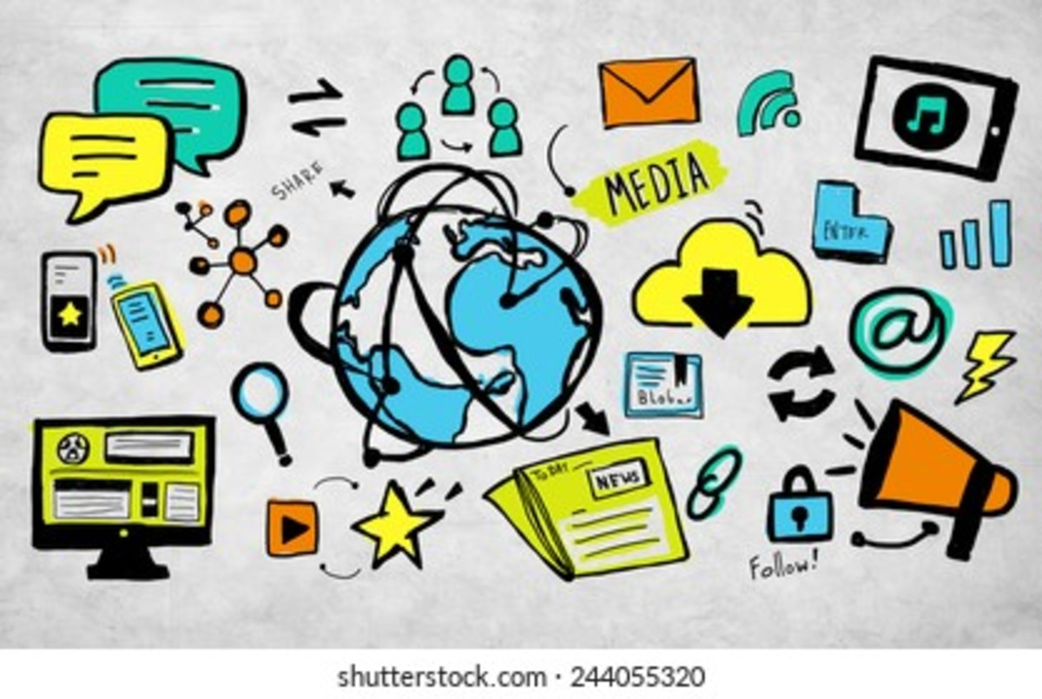

**Q4: What negative consequences does globalization have for the world in general?**

**Answer**: While offering numerous benefits, globalization also presents significant downsides, including the exacerbation of **economic inequality**, where the gap between wealthy corporations and nations and struggling developing economies can widen. It also contributes to **cultural homogenization**, as dominant global media can erode local traditions. Furthermore, increased industrial activity and global trade lead to **environmental degradation** through higher emissions and resource depletion, and the heightened movement of people and goods facilitates the rapid **spread of pandemics**.

**Q5: How do you think globalization has improved individuals' lives? Relate the answer to your daily life.**

**Answer**: Globalization describes the increasing worldwide interdependence of economies, cultures, and populations, driven by cross-border flows of goods, services, capital, technology, and people. It boosts economic integration, cultural exchange, technological spread, and political cooperation. However, it also brings challenges like economic inequality, cultural homogenization, environmental damage, and faster pandemic spread. For individuals, globalization means better access to diverse goods, improved communication, more opportunities, and cultural enrichment.

**Grammar**

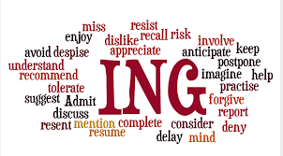

# Gerund

A **gerund** is a verb form that ends in **-ing** and functions as a **noun** in a sentence. Although it looks like a verb, it acts like a noun, which means it can serve as the subject, object, or complement in a sentence.

**Examples:**

1. **Swimming** is fun. (Gerund as the subject)
2. She enjoys **dancing**. (Gerund as the object)
3. His favorite activity is **reading**. (Gerund as the compliment)

In these examples, *swimming*, *dancing*, and *reading* are all gerunds because they take the verb form with an *-ing* ending but are used as nouns.

# Infinitive

An **infinitive** is the base form of a verb, usually preceded by the word "**to**." It can function as a **noun**, **adjective**, or **adverb** in a sentence. Infinitives are versatile and can be used to express actions or states in a more abstract way.

**Examples:**

1. **To learn** is important. (Infinitive as a noun, subject of the sentence)
2. She has a suggestion **to make**. (Infinitive as an adjective, describing "suggestion")
3. He came **to help**. (Infinitive as an adverb, explaining the reason for "came")

In these examples, *to learn*, *to make*, and *to help* are all infinitives, used in different roles within the sentences.



**Participle**

A **participle** is a verb form that functions as an **adjective** in a sentence, describing or modifying nouns or pronouns. Participles can also be used to form certain verb tenses.

There are two main types of participles:

1. **Present Participle**: Ends in **-ing** (e.g., *running*, *singing*).
2. **Past Participle**: Often ends in **-ed**, **-d**, **-t**, **-en**, or **-n** (e.g., *cooked*, *written*, *broken*), but there are many irregular forms.

**Examples:**

* + **Present Participle**: *The* ***running*** *water* was refreshing. (Describes "water")
  + **Past Participle**: *The* ***broken*** *vase* was on the floor. (Describes "vase")

### Participles in Verb Tenses:

* + **Present Participle**: Used in continuous tenses, e.g., *She is* ***singing****.*
  + **Past Participle**: Used in perfect tenses, e.g., *They have* ***eaten*** *dinner.*

**Question 1**

### They complimented me on my *singing*.

* + **Gerund** (acting as a noun)

**Jenny likes *to dance* in the rain.**

* + **Infinitive** (acting as a noun)

### There are many ways of *cooking* this dish.

* + **Gerund** (acting as a noun)

### A *broken* heart will mend over time.

* + **Participle** (acting as an adjective describing "heart")

### "Happiness is *having* a large, loving, caring, close-knit family in another city." – George Burns

* + **Gerund** (acting as a noun, complementing "Happiness is")

***Traveling is good for the mind.*\***

* + **Gerund** (acting as a noun, subject of the sentence)

***To arrive on time, Sam took the metro.*\***

* + **Infinitive** (acting as an adverb, explaining why Sam took the metro)

### We do not have the funding *to build* the proposed sports facility.

* + **Infinitive** (acting as an adjective describing "funding")

### The students were confused by the professor's *lecture*.

* + This sentence has no participle, gerund, or infinitive in italics. "Lecture" is a noun.

**He agreed *to wait* for a better time.**

* + **Infinitive** (acting as a noun, object of "agreed")

**Question 2**

## Gerunds

Gerunds are verbs that function as nouns and end in -ing. Here are the gerunds from the poem:

* + **trading** (from "trade")
  + **sharing** (from "share")
  + **communication** (functioning as a noun in "Communication")
  + **traveling** (from "traveling")
  + **finding** (from "find")

## Infinitives

Infinitives are the base form of a verb preceded by "to."

## Participles

Participles are verb forms that function as adjectives. In the poem, we can identify the following participles:

* + **connected** (in "Connected by the World")
  + **willing** (in "a community, that's strong and willing")
  + **fast** (in "a way to travel, that's fast and kind")
  + **bound**(in "that's bound forever")

**Group Work**

**Question 1: How do you think the ability to sell and purchase goods from the global market has influenced local business in Pakistan?**

**Answer:**

### Increased Competition

* + **Impact:** With easier access to international markets, local businesses face stiffer competition from foreign brands and products, often at competitive prices. This pushes Pakistani businesses to improve quality, lower costs, or find unique ways to stand out.
  + **Example:** Local electronics and clothing brands have to compete with imported alternatives, which sometimes offer higher quality or more competitive prices.

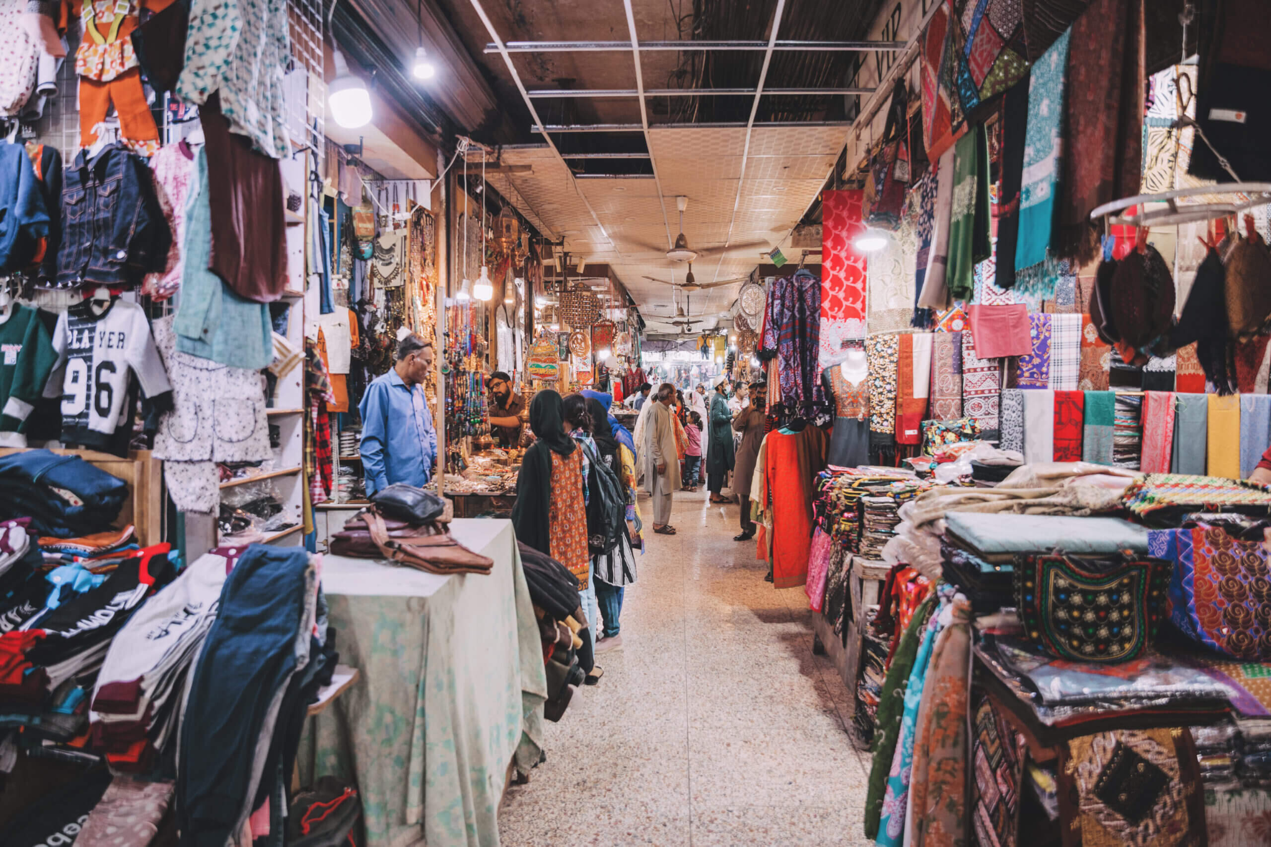

### Access to Broader Markets

* + **Impact:** Pakistani businesses now have the opportunity to export their goods globally, which opens up new revenue streams and reduces dependency on the local market.
  + **Example:** The textile industry in Pakistan, particularly in cities like Faisalabad and Karachi, has been able to expand through exports to Europe, the Middle East, and North America, bringing foreign revenue into the country.

### Technological Advancements

* + **Impact:** Exposure to international markets means local businesses can adopt new technologies, tools, and production methods to improve efficiency, productivity, and quality.
  + **Example:** The use of e-commerce platforms like Alibaba or Amazon has allowed Pakistani entrepreneurs to tap into global markets, promoting local handicrafts, textiles, and tech services to international consumers.

### Enhanced Consumer Choices

* + **Impact:** Access to global goods offers consumers a wider variety of products, from electronics to luxury goods, at varied price points. This shapes consumer expectations, prompting local businesses to keep up with trends and offer better quality.
  + **Example:** In the cosmetics industry, for instance, Pakistani brands now face competition from international brands, leading them to innovate and improve their own product offerings.

### Supply Chain and Resource Access

* + **Impact:** Globalization has enabled local businesses to source raw materials from across the world, sometimes at lower costs, leading to better production capabilities and competitive pricing.
  + **Example:** Pakistani jewelry manufacturers may source gemstones from countries like Thailand or Sri Lanka, enhancing the quality and appeal of their products in both local and global markets.



### Regulatory and Economic Challenges

* + **Impact:** Global trade requires adherence to international standards and regulations, which can be challenging for some local businesses that lack resources. Currency fluctuations and import tariffs also impact profitability.
  + **Example:** Pakistani exporters may face high costs due to fluctuating exchange rates, which can make it challenging to price their goods competitively in foreign markets.

**Question 2: Share a few examples of popular online selling hubs in Pakistan, and how they contributed to the digital economy.**

**Answer:** Popular online selling hubs in Pakistan have significantly contributed to the digital economy by making e-commerce accessible, creating jobs, and providing a platform for local businesses to reach wider audiences. Here are some of the major players and their impact:

### Daraz

* + **Overview:** Daraz is one of the largest e-commerce platforms in Pakistan, offering a wide range of products from electronics to fashion and groceries.
  + **Contribution:** By providing a marketplace for small and medium-sized businesses, Daraz has empowered local sellers, increased consumer access to goods, and promoted digital transactions. Daraz’s integration of various payment methods, including cash on delivery and mobile wallets, has also encouraged consumers to embrace online shopping.

### OLX Pakistan

### **Overview:** OLX is a classified platform where users can buy and sell items directly, ranging from real estate to used goods and services.

* + **Contribution:** OLX has fostered a culture of online buying and selling in Pakistan, popularizing peer-to-peer commerce. It has enabled individuals to participate in the digital economy without needing extensive infrastructure, which has supported the growth of second-hand goods markets and sustainable consumption.

### Foodpanda

* + **Overview:** Foodpanda is a food delivery platform that connects restaurants with consumers, offering everything from fast food to groceries and home-cooked meals.
  + **Contribution:** Foodpanda has expanded the digital economy by bringing a large number of restaurants, home chefs, and grocery stores online, particularly in urban areas. It has contributed to the gig economy by creating flexible jobs for delivery personnel, which boosts the income levels of many individuals and households.

### Zameen.com

* + **Overview:** Zameen.com is Pakistan’s leading real estate platform, where users can browse property listings, buy, sell, or rent properties, and connect with agents.
  + **Contribution:** Zameen.com has digitized the real estate sector, simplifying access to property information and boosting transparency in property transactions. This platform attracts significant foreign investment in the real estate sector, aiding economic growth and creating an organized, technology-driven property market.

### Bazaar and Tajir (B2B Platforms)

* + **Overview:** Bazaar and Tajir are B2B e-commerce platforms that allow retailers to source inventory directly from wholesalers and manufacturers.
  + **Contribution:** These platforms have improved the supply chain efficiency for

local retailers and small businesses, cutting out middlemen and lowering costs. By digitizing B2B commerce, they’ve contributed to the formalization and expansion of the wholesale market and empowered small shops to thrive in the digital economy.

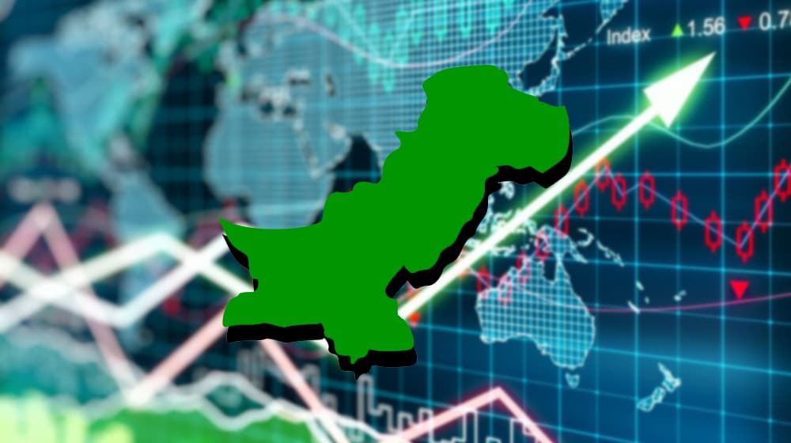

### Impact on Pakistan’s Digital Economy:

### **Increased Digital Transactions:** These platforms have popularized digital payments and banking options, making transactions faster and more secure.

* + **Job Creation and Gig Economy:** Platforms like Foodpanda and Daraz have provided income opportunities, from delivery services to digital marketing roles.
  + **Empowerment of SMEs:** By allowing even small businesses to list their products online, these platforms have made it possible for SMEs to reach national and international customers, expanding their market reach.
  + **Consumer Behavior Shift:** These hubs have also influenced a shift in consumer behavior toward online shopping, which supports further digital growth and innovation in the economy.

## Question 3: How does the expansion of mobile networks along with improved connectivity influence digital globalization in Pakistan?

**Answer:** The expansion of mobile networks and improved connectivity have greatly accelerated digital globalization in Pakistan, impacting business, education, and society at large.

Here’s how:

### Increased Access to Digital Markets

* + Impact: With extensive mobile network coverage, even people in remote and rural areas can access digital platforms and marketplaces. This has

democratized access to e-commerce, enabling individuals to buy and sell goods and services online.

* + Example: Many rural artisans now sell their handicrafts on platforms like Daraz and Facebook, reaching both local and international customers. This integration has allowed Pakistan’s products to reach a global audience, contributing to economic inclusivity and the digital economy.

### Growth of Mobile Payments and Fintech

* + Impact: The rise of mobile wallets like JazzCash and Easypaisa has brought more people into the digital financial system, making online transactions easier and more secure. This financial inclusion supports online shopping, mobile banking, and remittance services, linking Pakistan to the global economy.
  + Example: Small businesses and freelancers now use mobile payment solutions to receive international payments, facilitating participation in global trade and freelancing markets. This expansion has promoted Pakistan as a hub for online freelancing, especially in fields like IT, design, and digital marketing.

1. **Boost in the Gig Economy and Freelancing**

* Impact: Improved connectivity allows Pakistani professionals to work remotely for companies abroad, contributing to a thriving freelancing sector. Platforms like Upwork, Fiverr, and LinkedIn are widely accessible via mobile devices, giving Pakistanis greater access to global job markets.
* Example: Pakistan has become one of the top freelancing countries in the world, with many people in IT and creative fields taking on projects from clients globally, generating foreign exchange, and strengthening Pakistan’s digital economy.

### Enhanced Access to Education and Skill Development

* + Impact: Mobile networks facilitate access to online courses and training, helping Pakistanis acquire globally relevant skills. This educational access prepares the workforce to contribute to the global economy and raises the standards for domestic innovation.
  + Example: With platforms like Coursera, Udemy, and YouTube accessible on mobile, students and professionals in Pakistan can now learn skills in software development, data science, and digital marketing, which are in demand globally.

### Promotion of Digital Exports and Services

* + Impact: As connectivity improves, more Pakistani businesses are able to offer services like customer support, software development, and consulting to clients worldwide. This has opened up new revenue streams and positioned Pakistan as a competitive player in digital exports.
  + Example: Startups and established tech firms are now servicing clients across the globe, especially in regions like the Middle East and North America, providing digital services that contribute to Pakistan’s export economy.

### Social Media Influence and Cultural Exchange

* + Impact: With widespread connectivity, Pakistanis have increased access to global social media platforms like Facebook, Instagram, and TikTok. This facilitates

cultural exchange, influences consumer behavior, and increases global visibility for local businesses.

* + Example: Social media influencers in Pakistan promote local brands and connect with international audiences, which boosts tourism, cultural understanding, and

global awareness of Pakistani products and talent.

**Question 4: What challenges and risks does digital globalization pose to cybersecurity and data privacy in Pakistan?**

**Answer:** Digital globalization in Pakistan poses challenges to cybersecurity and data privacy due to increased cyber threats, such as hacking, phishing, and ransomware attacks. As more people and businesses go online, they face risks of data breaches and financial fraud, especially with limited cybersecurity awareness and infrastructure. Additionally, weak regulatory frameworks make it harder to protect personal data, leaving individuals and organizations vulnerable to misuse of information by third parties. Enhanced cybersecurity measures and stronger data protection laws are needed to address these risks.



### Question 5: What measures are being taken by the government to address cybersecurity concerns in Pakistan?

**Answer:** The Pakistani government is addressing cybersecurity concerns through initiatives like the National Cyber Security Policy, which aims to strengthen digital infrastructure and protect data. The establishment of the National Response Centre for Cyber Crimes (NR3C) under the Federal Investigation Agency (FIA) helps investigate and prevent cybercrimes. Additionally, the government is working on data protection laws to regulate data privacy and ensure secure digital transactions, alongside initiatives to raise public awareness about cybersecurity.

